**East West University**

**Design of a Full-Fledged Network with Subnets**

**Project Report**

**CSE405**

**Submitted by:**

|  |  |
| --- | --- |
| **Name** | **ID** |
| **Md.Amir Abdal Sobhani** | **2019-1-60-023** |

**Submitted to:**

Dr. Anisur Rahman

Assistant Professor

Department of Computer Science and Engineering

East West University

**Submission Date:** 14/5/2022

**Preface:**

The motive of this project was to get a comprehensive idea about how a complex networks work. Knowledge about how a complex network design can be practically implemented was also gained through doing this project. The network design that we proposed will hopefully satisfy all the necessary requirements and it will be as close of a real life implementation as possible.

**Objective:**

The primary objective was to design a complete model of a complex network by discovering the interconnectivity of the systems and sub-networks, which will reflect a university named the University of Professional structure and facilities.

On top of that, a webpage for University of Professional was to be made and it would be located through the address <http://www.universityofprofessional.edu>. Each Campus was also given a wireless access point to access the network. All the 6 campuses of the university were encompassed in the complex network along with sub-nets inside each campus.

**Physical Diagram:**

**Labels:**

- DHCP Server, - DNS Server, - Web Server

- Router - Switch

- End Device (PC) - Wireless Access Point

* Smart Device (Smart Phone)

**Implementation Details:**

The network design was implemented in Cisco Packet Tracer. To encompass all the 6 different campuses as well as connecting it to a separate Server Room. Three diagonal paths of the were also connected to provide alternate paths in case any of the routers go down. Each campus was given two sub-nets to differentiate the student PCs from the PCs used for Administration. A wireless Access Point was also provided in each campus through which other devices can connect to the network wirelessly.

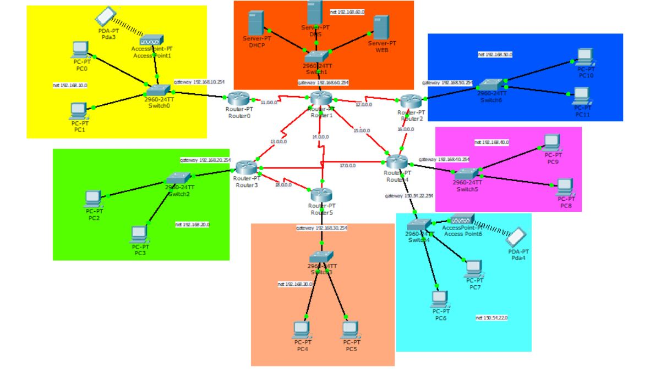

The Network elements used in the project were:

1. Connectors (Straight Through Cable and Serial DCE)
2. Routers
3. Switches
4. Servers
5. PCs
6. Wireless Access points
7. Smartphone

There were 3 servers that were used. Those were DHCP, DNS and Web Server. All these servers were kept in a Server Room. The DHCP server was used to dynamically provide IP addresses to all the hosts present in the 6 campuses including the different Sub-Nets in each campus.

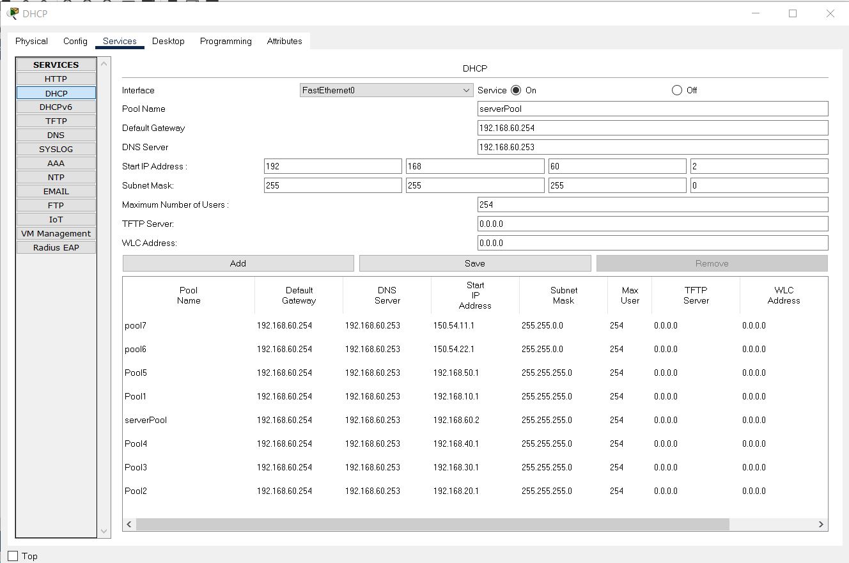

The Web Server was used to provide the webpage of University of Professional which can be accessed through any of the hosts in any network. The webpage had the required functionalities to display information about Admissions, Advising, Results, and Library etc.

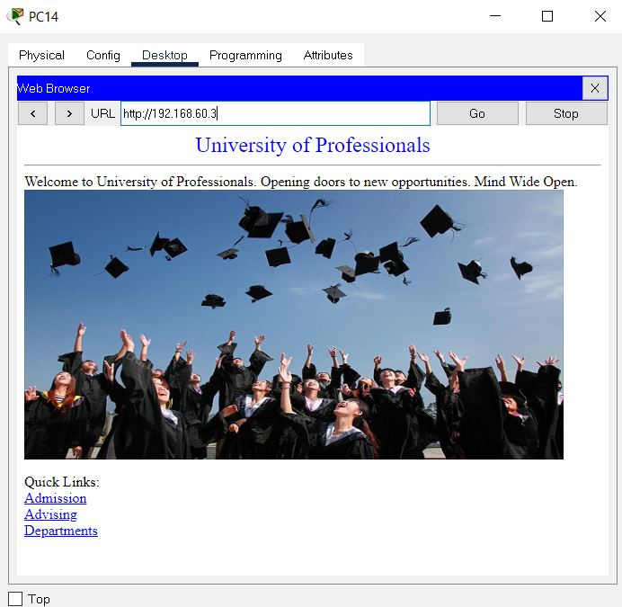

The DNS server was used so that all the hosts can access the webpage in the Web Server through the required web address instead of the IP address of the Web Server.

Each of the Routers had complex routing so that it can route to any of the other networks in the complex design. 3 diagonals of the routing design were connected and routing paths through those diagonals were also configured. This allowed for extra precautions and durability of the design and the routing would be still possible through alternate paths in case a router or more goes down.

In each of the campuses, the host PCs received their IP addresses dynamically through the single DHCP server. With this arrangement it is also possible to add new hosts in the network without the hassle of manually allocating IP addresses. The hosts also received information about the DNS server through the DHCP.

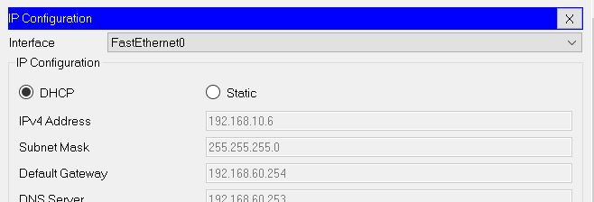

The wireless connections were possible through wireless Access Points present in each network. The Access Points were secured through WEP protection and the connecting devices would require password to connect to the wireless network.

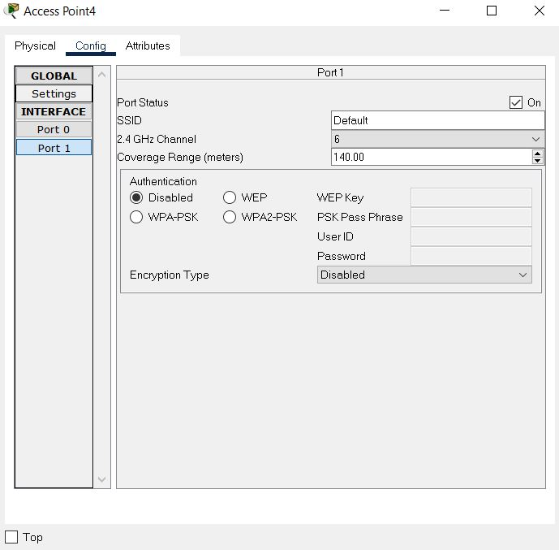

Thus, the entire network was properly connected and communications between any devices in the complex network was established.

**Special Requirements:**

As per the special requirements for creating this network,

* The servers were kept in a separate LAN in the form of a server room.
* Only a single DHCP server was used to dynamically provide IP address to hosts belonging to all the different networks.
* Network addresses were selected from 3 classes, Class A, Class B and Class C.
* Sub-Nets were incorporated in each of the Campus Networks.
* Complex mesh was designed with extra diagonal paths to ensure that the other communications do not go down even if a router or two stops working.

**Limitations:**

Due to lack of knowledge of advanced networking strategies and routing algorithms, a more efficient routing technique could not be implemented. As a separate Server Room was created for the servers, an added network was created. So, it may become expensive to maintain the extra Server Room network and excess precautions must be taken so that the Router connecting the Server Room does not go down.

**Conclusion:**

Overall, it can be concluded that the requirements for the complex network of University Of Professional were mostly met. The network design made was functional and it can provide an effective means of communication between the different university campuses. Various extra measures were taken to make the network more reliable and robust. Efficient networking techniques were learnt during the completion of this project and it undoubtedly enhanced our knowledge about networking.